Contemporary Japanese Ceramics and Metalwork

October 3 – November 9, 2019
Location: Onishi Gallery, 521 W. 26th Street, New York City
Gallery Hours: Wednesday - Saturday, 11am - 6pm (or by appointment)

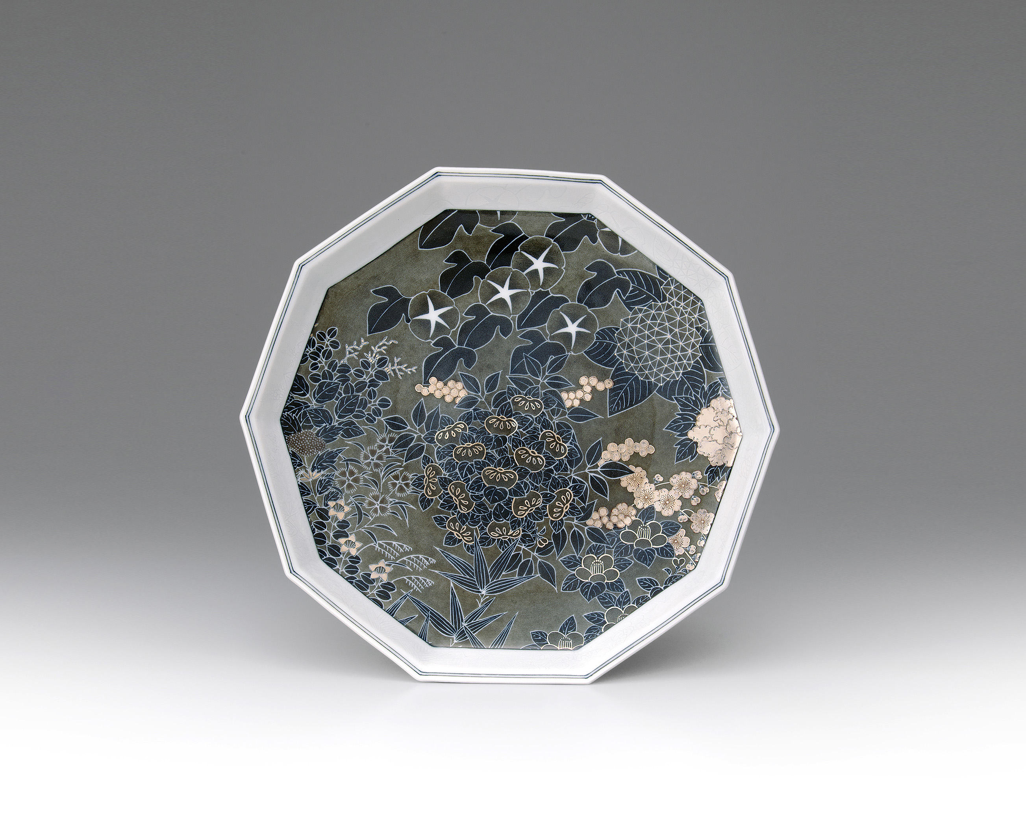
Image caption: Imaizumi Imaemon XIV (b. 1962), Living National Treasure; Plate with Snowflake and Four Seasons Flower Patterns, 2016; Porcelain with iro-e polychrome enamel painting with light sumi and sumi-hajiki; h. 1 7/8 x dia. 11 1/2 in. (5.6 x 29.3 cm)

Onishi Gallery is proud to present Contemporary Japanese Ceramics and Metalwork, bringing together both renowned and emerging talents to introduce their work to American audiences, connecting them with museum collections as well as enriching the Japanese art and culture in the United States.

In this exhibition, Onishi Gallery is pleased to include the work of five master-level artists who have been designated Living National Treasures by the Japanese government. Unparalleled in their craft, these artists have not only gained mastery over their chosen media, but their contributions are so significant that they constitute intangible cultural properties. These artists, many carrying on techniques that have been passed down through their families for generations, have not only preserved important cultural traditions, but have created new ways to interpret them.

In 2014, Imaizumi Imaemon XIV (b. 1962) became a Living National Treasure at the age of 51, making him the youngest artist in Japan to receive the honor. An expert in the Iro-Nabeshima style of polychrome ceramics, Imaizumi utilizes traditional techniques but also injects his own personal tastes, resulting in technically impressive pieces with truly unique designs. The 14th generation head of his family, Imaizumi’s work is in many museums’ permanent collections, including The National Museum of Modern Art in Tokyo, The Kyushu Ceramic Museum in Saga, The Museum of Ceramic Art in Hyogo, The British Museum in London and The Auckland Museum in New Zealand.
Yoshita Minori (b. 1932), who was designated a Living National Treasure in 2001, runs his Nishikiyama kiln, which specializes in aka-e kinrande, a highly decorative porcelain technique involving gold and red enamel painting in brocade-patterns on Kutani wares from Ishikawa. In 1951 he took over the family business and became the 3rd generation head of the family. Since then, he has been experimenting with various traditional techniques characteristic to the Nishikiyama Kiln while refining them in innovative ways. He is most notably recognized for his graceful application of yuri-kinsai, an under glazed gold decorative porcelain developed during the 1960s in Kanazawa, in which gold-leaf cutouts are applied prior to glazing rather than painted by brush. His selected public collections include the Embassy of Japan, Washington D.C., US; Smithsonian Institution, Washington D.C., US; British Museum, London, UK; Auckland Museum, New Zealand; Kyushu Ceramic Museum, Arita, Saga, Japan; National Museum of Modern Art, Tokyo, Japan and the Museum of Ceramic Art, Sasayama, Hyogo, Japan.

Tokuda Yasokichi III (1933–2009) was one of the world’s most famous of Kutani potters. Born in Ishikawa prefecture, he was designated a Living National Treasure in 1997 for his mastery of the saiyu glaze technique. Based on traditional Kutani colored glaze enamels, Yasokichi III developed techniques handed down from his grandfather, Tokuda Yasokichi I (1873–1956) and later his father,Tokuda Yasokichi II (1907–1997). Through his saiyu glaze techniques, Yasokichi III created his own designs characterized by delicate shading and the beautiful color contrasts of his vivid enamel glazes. Yasokichi III’s works have been recognized widely and shown in numerous museums including the British Museum, the Metropolitan Museum of Art, the Sackler Gallery, and the Smithsonian Institute.
The first female metalwork artist to be designated a Living National Treasure, Osumi Yukie (b. 1945), specializes in tankin, or hammered vessels. The recipient of numerous awards and accolades, she is known for her application of the traditional technique nunome-zogan or textile pattern inlay. This involves hammering metal leaf or wire into a fine, mesh-like grid incised into the surface of metal. Osumi creates both decorative and functional objects, such as vases and tea utensils. She likes to convey a sense of nature, which is formless and flowing, and does so through her designs of wind, waves, clouds and streams. Her works are in many public collections, including The National Museum of Modern Art, Tokyo, the Victoria & Albert Museum, London and The Royal Museum, Edinburgh.
Nakagawa Mamoru (b. 1947) is recognized for his outstanding mastery of zogan (metal-inlay) and was designated a Living National Treasure in 2004 at the age of 56, which is the second youngest in history. Nakagawa has been a seminal figure in revitalizing metal-inlay as an important genre of decorative arts in Japan since it’s decline during the Meiji Restoration period. He has enlivened the traditionally monotone realm of metal casting with an unprecedented palette of colors. His long list of public collections include the Metropolitan Museum of Art, New York, US; The British Museum, London, UK and the Victoria and Albert Museum, London, UK; 21st Century Museum of Contemporary Art, Kanazawa, Japan; Ishikawa Prefectural Museum of Art, Kanazawa, Japan and Kyushu Sangyo University, Fukuoka, Japan.
For more information, contact Nana Onishi at 212-695-8035 or nana@onishigallery.com. Or, please visit the gallery website at www.onishigallery.com. Or, please visit the gallery website at www.onishigallery.com.

